Table of contents

1. INTRODUCTION 2

1.1 AIM/ STATEMENT OF THE PROBLEM 2

1.2 OBJECTIVES 2

1.3 INTRODUTION TO PROBLEM DOMAIN 3

1.4 APPLICATIONS 3

1.5 EXISTING SOLUTION METHODS 3

1.6 PROPOSED SOLUTION METHODS 3

1.7 TIME SCHEDULE FOR COMPLETION OF THE PROJECT 3

2. LITERATURE SURVEY 4

3. SYSTEM REQUIREMENTS AND ANALYSIS 4

3.1. INTRODUCTION 4

3.1.1. Purpose 5

3.1.2. DOCUMENT COVENTIONS 5

3.1.3. INTENDED AUDIENCE AND READING SUGGESTIONS 5

3.1.4. PRODUCT SCOPE 5

3.2. OVERALL DESCRIPTION 5

3.2.1. Project Perspective 5

3.2.2. Product Functionality 5

3.2.3. User classes and characteristics 5

3.2.4. Operating Environment 6

3.2.5. DESIGN AND IMPLEMENTATION CONSTRAINTS 6

3.2.6. USER DOCUMENTATION 6

3.2.7. ASSUMPTIONS AND DEPENDENCIES 6

3.3. EXTERNAL INTERFACE REQUIREMENTS 7

3.3.1. USER INTERFACE 7

3.3.2. HARDWARE INTERFACES 7

3.3.3. SOFTWARE INTERFACES 7

3.3.4. COMMUNICATION INTERFACES 7

3.4. SYSTEM FEATURES 7

3.5. OTHER NON-FUNCTIONAL REQUIREMENTS 7

3.5.1. PERFORMANCE REQUIREMENTS 7

3.5.2. SAFETY REQUIREMENTS 8

3.5.3. SECURITY REQUIREMENTS 8

3.5.4. SOFTWARE QUALITY ATTRIBUTES 8

3.5.5. BUSINESS RULES 8

4. TOOLS AND TECHNOLOGY USED 8

4.1. IDE USED 8

4.1.1. Visual Studio Code 8

4.1.2. Jupyter Notebook 8

4.2. FRAMEWORKS USED 9

4.2.1. React JS 9

4.2.2. OpenCV 9

4.2.3. Python Flask 9

4.2.4. Tensorflow 10

4.3. LANGUAGES USED 10

4.3.1. HTML 10

4.3.2. CSS 10

4.3.3. JavaScript 10

4.3.4. Python 10

5. SYSTEM DESIGN 11

5.1. ANALYSIS 11

5.2. CONCEPTUAL DESIGN AND RESEARCH 11

5.3. DEVELOPMENT OF THE PROJECT 11

6. SYSTEM IMPLEMENTATION 13

6.1. REGISTRATION AND VALIDATION 13

6.2. DATA PRE-PROCESSING 13

6.3. LEARNING AND DRAW SECTIONS 15

6.4. NAVIGATION THROUGH HOME 16

6.5. IMPLEMENTATION OF ML ALGORITHM 17

6.6. PREDICTION AND ACCURACY 18

A. Appendix A: Project Team Details 19

B. Appendix B: COs, POs and PSOs Mapping for the Project Work (CS84P) 19

C. References 21

## INTRODUCTION

### AIM/ STATEMENT OF THE PROBLEM

To design and develop a web-based application that will achieve an activity based learning and focuses on using real-world objects to facilitate pre-school learning of the English alphabets, spellings, counting of numbers, recognition and drawing of real world objects.

### OBJECTIVES

* To train our model to identify and classify scribbled alphabets, digits, and drawings.
* To create two sections: Learning and Playing
* To design a system with friendly navigation, backgrounds, sounds and colours to attain the attention of kids while learning.
* To show the child’s progress after a certain period of time.

### INTRODUTION TO PROBLEM DOMAIN

Preschool age is critical for kid’s development. A good reading ability and understanding of any child depends on the training he/she receives. This requires the parents to invest more time and money on materials and tools. With the rapid growth in technology today, learning and teaching materials has shifted from the black board to more sophisticated gadgets that support teaching and learning at any level of learning, starting from the preschool to the higher learning. With time, a kid’s way of learning also has changed and demand more interactive and a playful environment to learn.

### APPLICATIONS

* Convenient for students E-learning materials are self-placed and can be accessed any time the learner wants. They do not require the learner to be physically present in a classroom.
* Lower cost E-learning is usually a cost-efficient way of learning for most students as they can choose from a large range of courses and make the selection depending on their needs. It can also be cost-efficient for many schools because once the learning platforms are set up, they can be reused for many sessions.
* Up-to-date learning materials -The study materials in e-learning systems can be updated more frequently than in the classroom-based education systems. Once the study materials are placed in the system, they can be updated without changing the whole materials and the materials can be available and reused for longer times.
* Flexible way of learning E-learning is a flexible way of learning for many students. Most of the study materials are stored for the students to access whenever they want. In e-learning systems it is also possible for students to skip over the study materials they already know and choose the ones they want to learn.
* World-wide learning society E-learning systems help in creating a worldwide learning society as anyone can access the study materials regardless of the geographical location. In the systems available now learners can also contribute to the study materials, which helps to keep the materials updated.
* Scalable e-learning systems The number of students in virtual classes or e-learning systems can be very few or really high without causing any significant difference in the total cost.

### EXISTING SOLUTION METHODS

There has been several previous works done in the field of e-learning and analysis. There are several approaches that were followed by different researchers. After referring to many review papers we have concluded that the methods are the existing solution for an e-learning website. Other existing solutions are maintaining good customer relationship, customer experience, transparency, and comfort of the customers. These are all already existing solutions for an efficient e-learning website.

### PROPOSED SOLUTION METHODS

How different is our website from the existing ones? What components are we adding that makes our website different from the existed ones? We are developing an online website for pre-school kids where they can draw and learn. For example the existing websites include reading modules. Ours includes activity-based learning where the kid can draw and learn at the same time.

We have trained the model to identify and classify scribbled alphabets, digits, and simple drawings. The main aim is to enable children to become active and take full advantage of the online learning platform available today.

### TIME SCHEDULE FOR COMPLETION OF THE PROJECT

The final year project and the idea submission phase started in the last week of November and the synopsis of the project was submitted on 5th December 2020.The time feasibility will consider the period in which the project is going to take up to its completion. The timeline for our project is as follows:-

Requirements Gathering: The gathering of requirements is the most important phase in the project making as it lays the foundation. For the requirements we contacted the stakeholder virtually who is a teacher or a parent to give us an insight about the requirements and expected solutions. The requirement collection was done by 2nd week of December.

System Analysis and design: As the project focuses on web development and machine learning, it’s necessary to have a deep knowledge about the same before working on the project. This phase was done by 4th week of December.

Implementation: As we are well versed with the tech stack, we will begin with the first phase of the project by working on the modules as promised.

* Validation(during login): It focuses on providing genuine authentication for the users. This was done by 2nd week of January.
* Data pre-processing: It requires that we process the collected data before using it in the ML algorithm. This was done by the 2nd week of March.
* Navigation between components, backend implementation, Training and testing of CNN models. This was done by 2nd week of May.

## LITERATURE SURVEY

The authors "Anchit Shrivastava, Isha Jaggi, Shefali Gupta, Deepali Gupta" analysed the most suitable and best method for digit recognition by considering 60,000 images for training set with a pixel size of 28×28. The images/training sets were matched with the original image. It was found out after complete analysis and review that the classifier ensemble system has the least error rate of just 0.32%. They also reviewed different methods of handwritten digit recognition.

The authors “Tsung-Han Tsai, Po-Ting Chi, Kuo-Hsing Cheng” built a sketch classifier technique with deep learning models. They had used the depth-wise convolution layer to lighten the deep neural network. The result showed the improvement in approximately 1/5 of computation. They had used Google Quick Draw dataset to train and evaluate the network, which can have 98% accuracy in 10 categories and 85% accuracy in 100 categories. The system can achieve real-time implementation of sketch classification.

The authors Olisah Kingsley S and Mohamed Ismail Z conducted a review on three possible solutions that can improve learning and teaching in pre-schools. The report also developed the most appropriate solution that will answer the research questions. Their research shall also discuss the importance and impact of information and communications technology on teaching and learning in pre-schools. It also discussed the advantages and disadvantages of web-based e-learning system over traditional kids learning.

The authors "Rahul Chauhan, Kamal Kumar Ghanshala, R.C Joshi" built CNN models to evaluate its performance on image recognition and detection datasets. The algorithm is implemented on MNIST and CIFAR-10 dataset and its performance is evaluated. The accuracy of models on MNIST is 99.6 %, CIFAR-10 is using real-time data augmentation and dropout on CPU unit.

The authors "Kristine Guo, James WoMa, Eric Xu" from Stanford University, built a multi-class classifier to assign hand-drawn doodles from Google’s online game Quick, Draw! into 345 unique categories. To do so, we implement and compare multiple variations of k-nearest neighbours and a convolutional neural network, which achieve 35% accuracy and 60% accuracy, respectively. They also evaluated the models’ performance and learned features.

## SYSTEM REQUIREMENTS AND ANALYSIS

### INTRODUCTION

#### Purpose

The main purpose of this document is to describe the characteristics of our project “Learning can be fun”, Which is an web based application using deep learning that will achieve an activity based learning and focuses on using real-world objects to facilitate learning of the English alphabets, spellings, counting of numbers, recognition and drawing of real world objects.

#### DOCUMENT COVENTIONS

This documentation is strictly within the guidelines and as per the standards of IEEE template for System Requirement Specification.

#### INTENDED AUDIENCE AND READING SUGGESTIONS

Target audiences:

* Pre-school kids : To develop cognitive and psychomotor skills.
* Parents and teachers : To observe the child’s progress after a certain period of time.

#### PRODUCT SCOPE

* Preschool age is critical for kid’s development. A good reading ability and understanding of any child depends on the training he/she receives. This requires the parents to invest more time and money on materials and tools. With the rapid growth in technology today, learning and teaching materials has shifted from the black board to more sophisticated gadgets that support teaching and learning at any level of learning, starting from the preschool to the higher learning. With time, a kid’s way of learning also has changed and demand more interactive and a playful environment to learn.
* Hence, we have come up with a Machine learning model to-
  + design and develop a web based application that will achieve an activity based learning and focuses on using real-world objects to facilitate pre-school learning.
  + improve the efficiency of teaching and learning at the pre-school level and maximizing the speed of learning in growing kids.

### OVERALL DESCRIPTION

#### Project Perspective

The project tries to identify alternate and effective ways for learning and education for children of age group below 8.The main aim is to enable children to become active and take full advantage of the online learning platform available today.

#### Product Functionality

* Train the model to identify and classify scribbled alphabets, digits and simple drawings.
* Enable 2 categories: Learning, Drawing.
* In the learning section, provide different images / drawings to the user online and wait for the user to draw the same on the plain canvas space available.
* Based on the image drawn by the user, determine, using machine learning algorithm and a huge data-set, whether it matches the original object.
* A similar approach is taken in the Drawing section: The user is provided with only the name of the object (not the image), and the user has to correctly draw the object in the canvas space available in a simple manner.
* Over time, the progress of the user is stored and a report is given periodically.

#### User classes and characteristics

* Students – This will help children of age below 8 years to develop intellectual and creative knowledge of objects and other elements essential in day-to-day life.
* Parents and teachers – This will help them to observe the child’s progress after a certain period of time.

#### Operating Environment

* Full connection to the internet.
* Good quality hardware for accurate drawing and prediction.

#### DESIGN AND IMPLEMENTATION CONSTRAINTS

* Improper internet connection.
* Improper AI prediction due to data anomaly.

#### USER DOCUMENTATION

It provides an introductory as well as a future reference to the user on how to use the application to your fullest advantage. It is used to assist users to use the product or service for self-development.

User documentation is important because it provides an avenue for users to learn:

1. How to use your web application.
2. Features of your web application.
3. How to resolve common problems with your software

**Training the model :**

The machine learning program using deep learning concepts to identify the images.

The algorithms are implemented using various Convolutional Neural Networks and choosing best one which gives good accuracy and better results for our data-set.

The training of data-set consists of thousands of images in .png format which are used to train our model with the doodles.

We make use of a canvas element to capture the drawing drawn by the user.

This is converted to an image and later to a 28×28 pixel format matrix.

This image is tested and the model predicts the drawing's label with a threshold of 60% accuracy.

It also predicts what other object does it resemble to, to give the user a better learning experience.

As soon as the user logs in with their registered id and a password, they will be directed to their profile which will contain their points, progress chart, rank in the leader board, and also two sections, namely: Learning and Drawing.

**Learning section:** The user gets to choose what he/she wants to learn from the given options and will be directed to a drawing area where they will be shown how to draw what they have chosen. Later they will be asked to draw the same. If correctly drawn, a success message will be shown, and that section will be marked as “DONE”. And they can learn more or come back to their profile.

**Drawing section:** The user will be shown three levels: Easy, medium, hard. Based on the level the user chooses, challenges will be given to them. If they draw it correctly a certain amount of points based on the level will be added to their profile. If wrong, they can try again or go back.

The model uses image processing and machine learning algorithms to get trained and recognize and classify the drawing drawn by the kid.

**Troubleshooting:** In this section, we help users fix common issues that may arise which are as follows:

You need a stable internet connection for the frames to be processed and predicted.

#### ASSUMPTIONS AND DEPENDENCIES

This model is developed in Python and uses various packages relevant to machine learning. It uses a modular design where every feature is wrapped into a separate module and the modules depend on each other through well-written program. There are several linkable programs available to make user interface easy.

### EXTERNAL INTERFACE REQUIREMENTS

#### USER INTERFACE

* The user interface for the software shall be compatible to any browser such as Internet Explorer, Mozilla by which user can access the system.
* The user interface shall be implemented using any tool or software package like Java Applet, MS Front Page, EJB etc.

#### HARDWARE INTERFACES

* The minimum hardware requirements for this are:
* Processor:  Dual Core
* RAM: Min 2GB
* Hard Disk:  20mb
* A browser which supports HTML, JavaScript
* Since the application must run over the internet, all the hardware shall require to connect internet will be hardware interface for the system. As for e.g. Modem, WAN – LAN, Ethernet Cross-Cable.

#### SOFTWARE INTERFACES

* Operating System: Windows
* Programming Language: Python, HTML, CSS, JavaScript, NodeJS, ReactJS
* Back End:
  + Software: Jupyter Notebook
  + Server: Xampp

#### COMMUNICATION INTERFACES

The system shall use the HTTP protocol for communication over the internet and for the intranet communication will be through TCP/IP protocol suite.

### SYSTEM FEATURES

* Processor:  Dual Core
* RAM: Min 2GB
* Hard Disk:  200mb
* Speed:  Min 1.1 GHz+
* Operating System: Windows
* Programming Language: Python, Html, CSS, ReactJS, NodeJS, Javascript
* Database: MySQL
* Software: Jupyter Notebook
* Server:
  + Neural Networks and image processing techniques are implemented to recognize the sketched images.

### OTHER NON-FUNCTIONAL REQUIREMENTS

#### PERFORMANCE REQUIREMENTS

* Our website, to predict properly requires a stable internet connection for transferring sketched images to the server.
* The application should minimize the start-up and response time and application should not display scrolling jerks longer than 200ms.
* Powerful servers to manage the data efficiently.
* We need a powerful processor to train the neural network model with large data-sets.
* Latest version of Google Chrome or Morzilla Firefox for better results.
* The performance shall depend upon hardware components of the client/user.

#### SAFETY REQUIREMENTS

* Information transmission should be securely transmitted to server without any changes in information.
* If there is extensive damage to wide portion of the database due to failure such as disk crash, the recovery method restores a past copy of the databases that was backed up to archival storage and reconstructs a more current state by reapplying or redoing the operations of committed transactions from the backed up log, up to the time of failure.

#### SECURITY REQUIREMENTS

* The system shall use secure sockets in all transactions that include any confidential customer information.
* The system shall automatically log out all customers after a period of inactivity.
* The system shall not leave any cookies on the customer’s computer containing any of the user’s confidential information.
* The system’s back-end servers shall only be accessible to authenticated administrators.
* The system’s back-end databases shall be encrypted.

#### SOFTWARE QUALITY ATTRIBUTES

* AVAILABILITY: The software should be available to all the users who are interested to learn.
* CORRECTNESS: The software should detect correctly the pictures drawn by kids with maximum accuracy.
* MAINTAINABILITY: The administrators should maintain the software correctly so that they get most out of it.
* USABILITY: The software should satisfy a maximum number of user’s needs.

#### BUSINESS RULES

* Our organization does not charge any fee in the name of commission for the service offered.

## TOOLS AND TECHNOLOGY USED

### IDE USED

#### Visual Studio Code

Visual Studio Code is a lightweight but powerful source code editor which runs on your desktop and is available for Windows, macOS and Linux. It comes with built-in support for JavaScript, TypeScript and Node.js and has a rich ecosystem of extensions for other languages (such as C++, C#, Java, Python, PHP, Go) and runtimes (such as .NET and Unity).

#### Jupyter Notebook

The Jupyter Notebook is an open-source web application that allows you to create and share documents that contain live code, equations, visualizations, and explanatory text. Uses include data cleaning and transformation, numerical simulation, statistical modelling, machine learning and much more. It provides you with an easy-to-use, interactive data science environment across many programming languages that doesn't only work as an IDE, but also as a presentation or education tool

### FRAMEWORKS USED

#### React JS

* React.js is an open-source JavaScript library that is used for building user interfaces specifically for single-page applications. It’s used for handling the view layer for web and mobile apps. React also allows us to create reusable UI components.
* React allows developers to create large web applications that can change data, without reloading the page. The main purpose of React is to be fast, scalable, and simple. It works only on user interfaces in the application.
* React.js is component based
* React.js supports server side

**Virtual Document Object Model**: React creates an in-memory data structure cache which computes the changes made and then updates the browser. This allows a special feature that enables the programmer to code as if the whole page is rendered on each change whereas react library only renders components that actually change.

#### OpenCV

* OpenCV is a cross-platform library using which we can develop real-time computer vision applications. It mainly focuses on image processing, video capture and analysis including features like face detection and object detection.
* OpenCV is the huge open-source library for the computer vision, machine learning, and image processing and real-time operation which is very important in today’s systems.
* Using it, we can process images and videos to identify objects, faces, or even handwriting of a human.
* It is integrated with various libraries such as Numpy, python and hence is capable of processing the OpenCV array structure for analysis.

#### Python Flask

* Flask is a popular Python web framework, meaning it is a third-party Python library used for developing web applications.
* Unlike the Django framework, Flask is very Pythonic. It’s easy to get started with Flask, because it doesn’t have a huge learning curve.
* On top of that it’s very explicit, which increases readability.
* Flask has a lightweight and modular design, so it easy to transform it to the web framework you need with a few extensions without weighing it down
* Basic foundation API is nicely shaped and coherent.
* Flask documentation is comprehensive, full of examples and well structured. You can even try out some sample application to really get a feel of Flask.
* It is super easy to deploy Flask in production (Flask is 100%WSGI 1.0 compliant”)
* HTTP request handling functionality
* High Flexibility  
  The configuration is even more flexible than that of Django, giving you plenty of solution for every production need.

#### Tensorflow

TensorFlow is an open-source machine learning framework for all developers. It is used for implementing machine learning and deep learning applications. To develop and research on fascinating ideas on artificial intelligence, Google team created TensorFlow. TensorFlow is designed in Python programming language, hence it is considered an easy-to-understand framework.

### LANGUAGES USED

#### HTML

The HyperText Markup Language is the standard [markup language](https://en.wikipedia.org/wiki/Markup_language) for documents designed to be displayed in a [web browser](https://en.wikipedia.org/wiki/Web_browser). It can be assisted by technologies such as [Cascading Style Sheets](https://en.wikipedia.org/wiki/Cascading_Style_Sheets) (CSS) and [scripting languages](https://en.wikipedia.org/wiki/Scripting_language) such as [JavaScript](https://en.wikipedia.org/wiki/JavaScript).

[Web browsers](https://en.wikipedia.org/wiki/Web_browser) receive HTML documents from a [web server](https://en.wikipedia.org/wiki/Web_server) or from local storage and [render](https://en.wikipedia.org/wiki/Browser_engine) the documents into multimedia web pages. HTML describes the structure of a [web page](https://en.wikipedia.org/wiki/Web_page) [semantically](https://en.wikipedia.org/wiki/Semantic_Web) and originally included cues for the appearance of the document.

[HTML elements](https://en.wikipedia.org/wiki/HTML_element) are the building blocks of HTML pages. With HTML constructs, [images](https://en.wikipedia.org/wiki/HTML_element#Images_and_objects) and other objects such as [interactive forms](https://en.wikipedia.org/wiki/Fieldset) may be embedded into the rendered page. HTML provides a means to create [structured documents](https://en.wikipedia.org/wiki/Structured_document) by denoting structural [semantics](https://en.wikipedia.org/wiki/Semantics) for text such as headings, paragraphs, lists, [links](https://en.wikipedia.org/wiki/Hyperlink), quotes and other items. HTML elements are delineated by *tags*, written using [angle brackets](https://en.wikipedia.org/wiki/Bracket#Angle_brackets). Tags such as <**img** /> and <**input** /> directly introduce content into the page. Other tags such as <**p**> surround and provide information about document text and may include other tags as sub-elements. Browsers do not display the HTML tags but use them to interpret the content of the page.

#### CSS

CSS is the language for describing the presentation of Web pages, including colors, layout, and fonts. It allows one to adapt the presentation to different types of devices, such as large screens, small screens, or printers. CSS is independent of HTML and can be used with any XML-based markup language.

#### JavaScript

JavaScript is mainly used for web-based applications and web browsers. But JavaScript is also used beyond the Web in software, servers, and embedded hardware controls.

Alongside [HTML](https://en.wikipedia.org/wiki/HTML) and [CSS](https://en.wikipedia.org/wiki/CSS), JavaScript is one of the core technologies of the [World Wide Web](https://en.wikipedia.org/wiki/World_Wide_Web). JavaScript enables interactive [web pages](https://en.wikipedia.org/wiki/Web_page) and is an essential part of [web applications](https://en.wikipedia.org/wiki/Web_application). The vast majority of [websites](https://en.wikipedia.org/wiki/Website) use it for [client-side](https://en.wikipedia.org/wiki/Client-side) page behaviour, and all major [web browsers](https://en.wikipedia.org/wiki/Web_browser) have a dedicated [JavaScript engine](https://en.wikipedia.org/wiki/JavaScript_engine) to execute it.

As a multi-paradigm language, JavaScript supports [event-driven](https://en.wikipedia.org/wiki/Event-driven_programming), [functional](https://en.wikipedia.org/wiki/Functional_programming), and [imperative](https://en.wikipedia.org/wiki/Imperative_programming) [programming styles](https://en.wikipedia.org/wiki/Programming_paradigm). It has [application programming interfaces](https://en.wikipedia.org/wiki/Application_programming_interface) (APIs) for working with text, dates, [regular expressions](https://en.wikipedia.org/wiki/Regular_expression), standard [data structures](https://en.wikipedia.org/wiki/Data_structure), and the [Document Object Model](https://en.wikipedia.org/wiki/Document_Object_Model) (DOM).

#### Python

Python is a general-purpose coding language—which means that, unlike HTML, CSS, and JavaScript, it can be used for other types of programming and software development besides web development.

That includes back-end development, software development, data science and writing system scripts among other things.

Python has pre-built libraries and web frameworks including Pyramid, [Django, and Flask](https://www.codementor.io/garethdwyer/flask-vs-django-why-flask-might-be-better-4xs7mdf8v), it’s especially great for using on back end web development projects, shortening the amount of time you spend on projects by allowing you to repurpose chunks of code. Python is used for machine learning via specific machine learning libraries and frameworks including scikit-learn and TensorFlow.

## SYSTEM DESIGN

The web-based application is an e-learning website for kids. We have a lot of research papers on this topic ana different techniques to conduct them. The requirements have been collected from the various stakeholders and have given a clear idea to work it. The technical aspect needed for our project is as follows:

• Operating System: We have chosen Windows operating system because it is easy to use and understand and all the required technology needed to complete the project is very well made for windows.

• ReactJS: The frontend technology for the website as it is SPA (single page application) allowing us to make the application more user- friendly.

• Database: We have decided to opt for MongoDB as our database as it provides us the flexibility to go schema-less design for our models. The methodology used to develop this website are as follows :

### ANALYSIS

After an effective conversation with a stakeholder, our team was able to analyze the requirements of the stakeholder, make all the requirements to the customer available on our website and recommend what will be needed to fulfil their needs. This phase includes the requirement analysis of both the admin and kids.

### CONCEPTUAL DESIGN AND RESEARCH

We as a team will go through the analysis done before and create a storyboard starting from the homepage. We will start with how the authentication flow will take place, how the products will be presented, and then finally will look into the flow of the checkout process. This will present the overall structure of our website and also provide the best chance for the stakeholder to discuss any changes that are required. The research is done from free research firms such as Quora, stack overflow, GitHub, etc, and by going through some of the papers by various authors.

### DEVELOPMENT OF THE PROJECT

In this, the coding phase begins, and the database designs are created. This phase is where all the discussions have been done and are converted into a reality where each page is now served dynamically and hence, they are database driven. Since the discussion phase will be done extensively with the stakeholder as well as with the team it would become much easier for the programmer to produce results quickly and efficiently. The flow of the implementation is as follows:

Figure 1: System flow of implementation

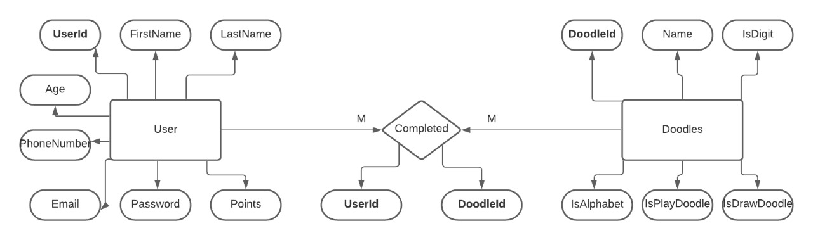

Figure 2: The schema of the implementated tables in mySQL database

## SYSTEM IMPLEMENTATION

### REGISTRATION AND VALIDATION

Figure 3: Register form to sign up.

After registering the user can login with a valid username and password.

Figure 4:Login page for user.

### DATA PRE-PROCESSING

The data sets are taken from Google quickdraw for doodle recognition, Kaggle datasets for digit and alphabet recognition.

They are manually divided into three categories as easy, medium, and hard With 30 categories each.

We randomly shuffle the data and take 70% for training and the rest for testing.

The images are pre-processed into 28 x 28 pixel matrices and converted into Gray scale images.as we don’t need colour for feature extraction in our project.

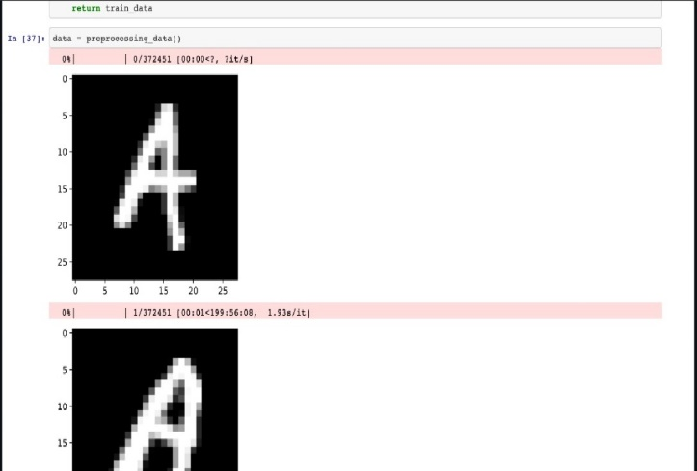

Figure 5:Data for Alphabets

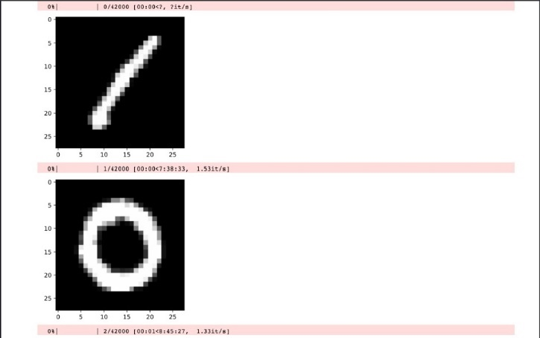

Figure 6: Data for digits

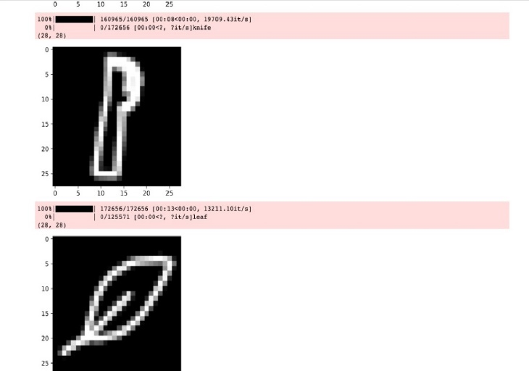

Figure 7:Data for doodle

### LEARNING AND DRAW SECTIONS

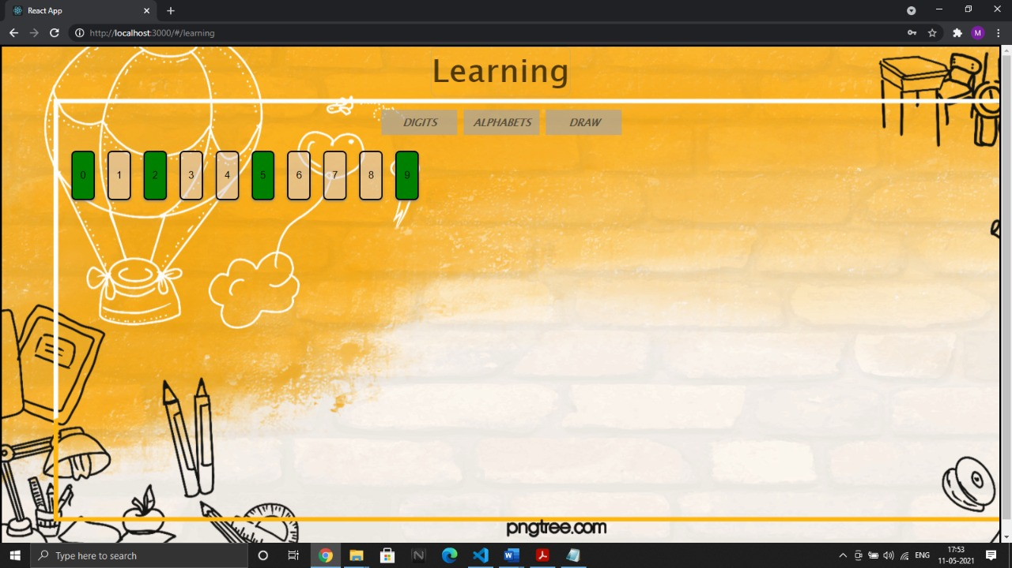The user gets to learn from various categories. The kid can learn digits and alphabets to begin with, and later move on to objects.

Figure 8: Learning section of digits

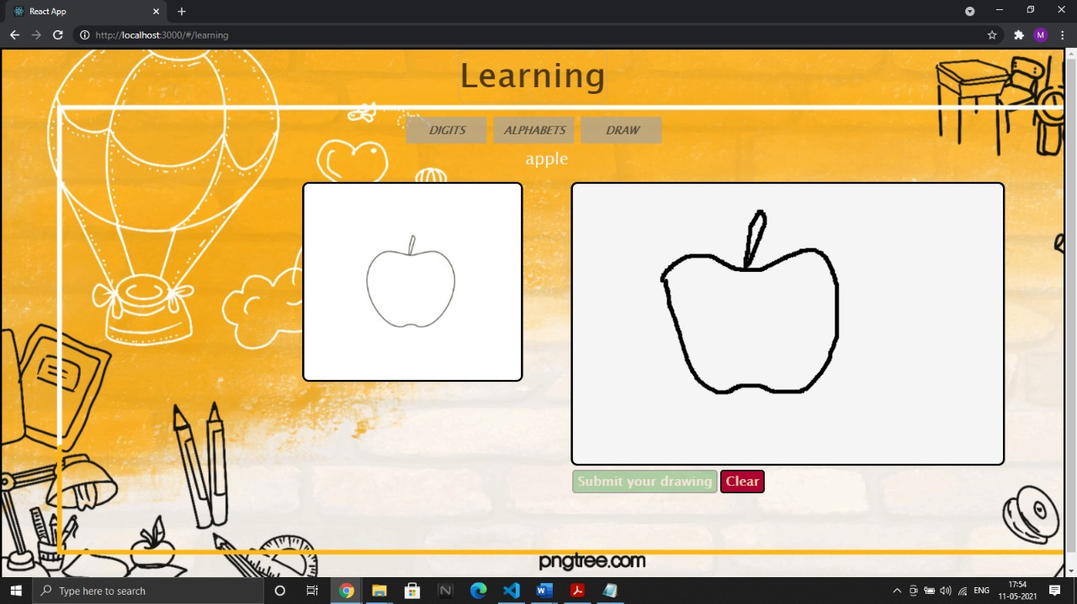

Figure 9: Learning section with canvas

The user can practice whatever they’ve learnt in the drawing section for which they will be awarded with points on successfully drawing it.

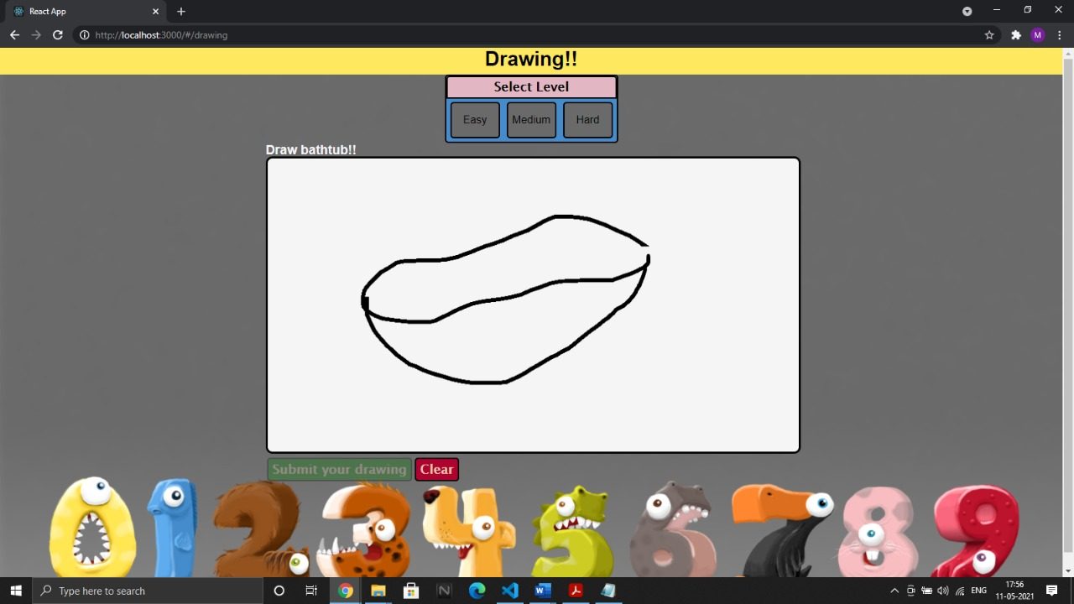They can choose the level of difficulty before they try to draw.

Figure 10: Drawing Section with three levels of difficulty

### NAVIGATION THROUGH HOME

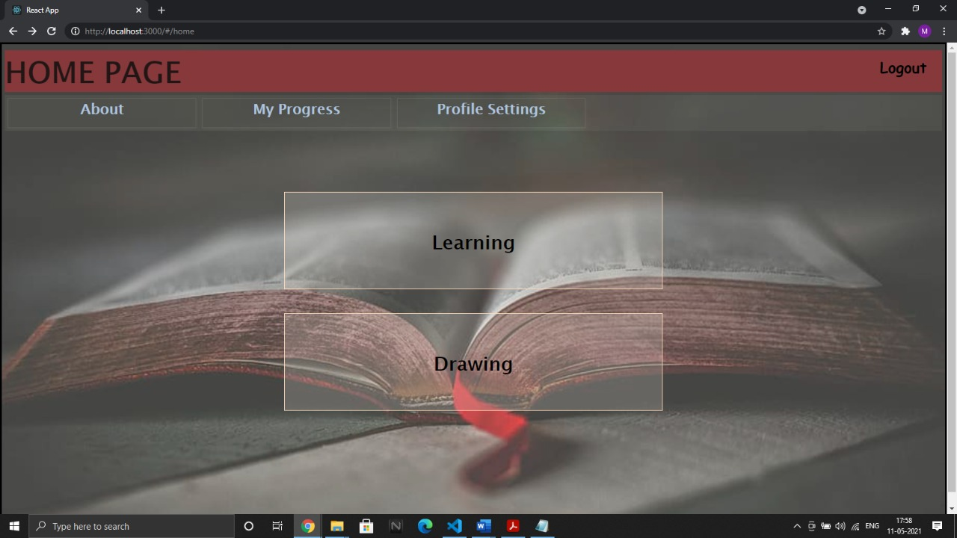On successfully logging in with a valid username and password, the home page shows up which is the anchor between all the components.

Figure 11: Home page for users to navigate between components

### IMPLEMENTATION OF ML ALGORITHM

After the data sets are pre-processed, they are divided into two lists: training and testing. The training data set is used to train the data model in the CNN with three layers.

It is run for a few epochs considering the size and computation time required for running each model.

A separate model is trained for each category i.e, for recognizing handwritten digits, alphabets and drawn doodles.

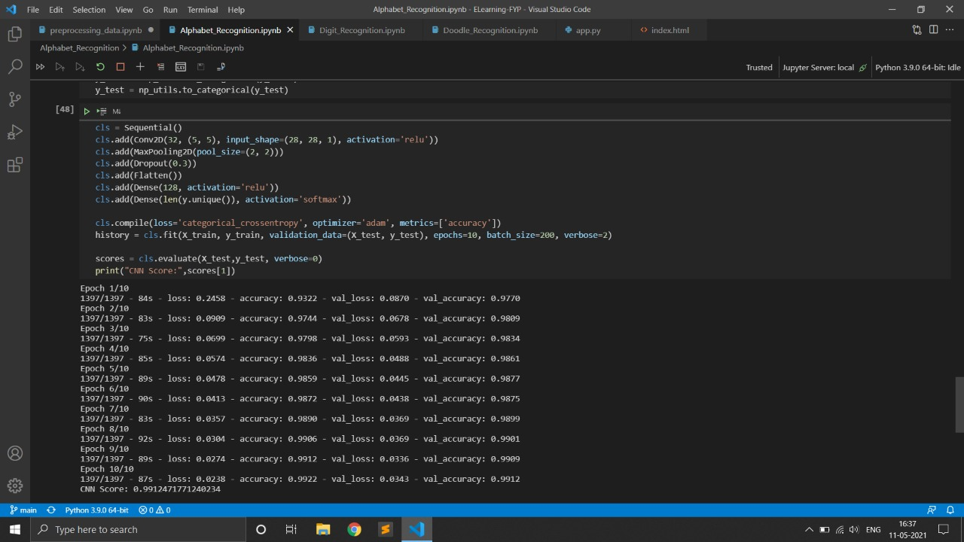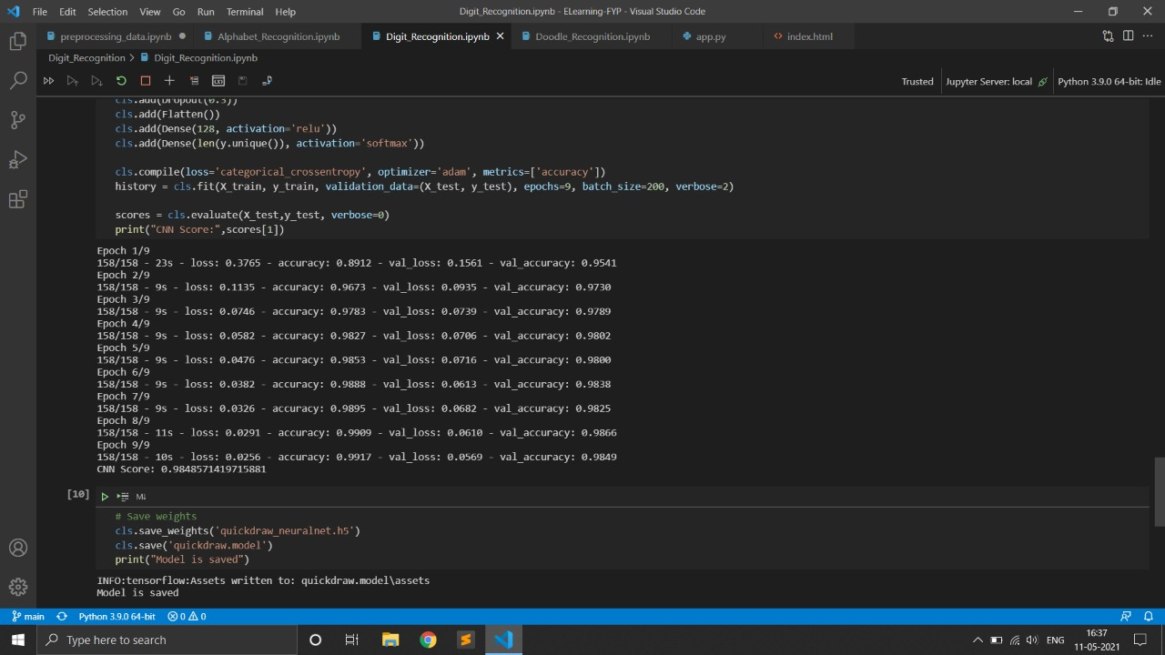Then using the testing data set, the model is tested for accuracy and performance.

Figure 12:Model for Alphabet recognition

Figure 13:Model for Digit recognition

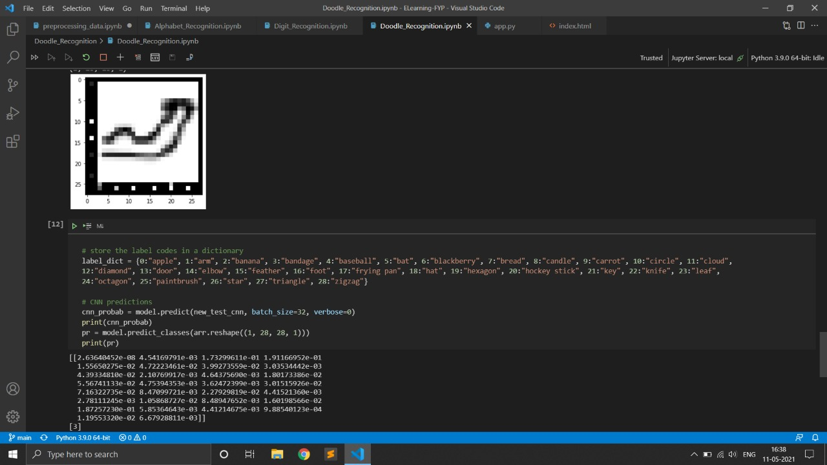

Figure 14:Model for doodle recognition

### PREDICTION AND ACCURACY

Figure 15:Accuracy of doodle recognition

After the model is trained, we are testing the model to get the accuracy of its prediction which are as follows:

* Digit : 98%
* Alphabet: 99%
* Doodle: 80%

## Appendix A: Project Team Details

|  |  |  |  |
| --- | --- | --- | --- |
| **Project Title** | **“Learning Can be Fun ”** | | |
| **USN** | **Team Members Name** | **E-Mail Id** | **Mobile Number** |
| 01JST17CS103 | PAAVANA M | paavana111[@gmail.com](mailto:anushams279@gmail.com) | 7349065465 |
| 01JST17CS153 | SONA AGRAWAL | [agrawalsona02@gmail.com](mailto:agrawalsona02@gmail.com) | 8310129178 |
| 01JST17CS177 | VISHAK S | vishakshashikumar5042[@gmail.com](mailto:manasakanathur@gmail.com) | 9481876306 |
| 01JST17CS180 | YASHWANTH H.L | yashwanth42078[@gmail.com](mailto:thurzdaymc1@gmail.com) | 7892622562 |

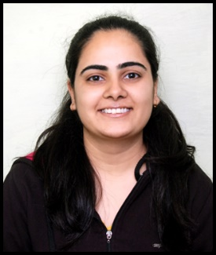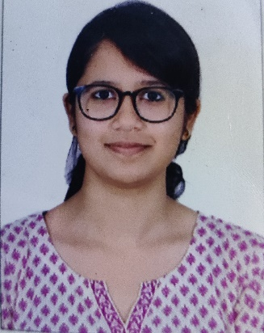

**VISHAK S 01JST17CS177**

**YASHWANTH 01JST17CS180**

**SONA AGRAWAL 01JST17CS153**

**Paavana M 01JST17CS103**

## Appendix B: COs, POs and PSOs Mapping for the Project Work (CS84P)

Course Outcomes:

CO1: Formulate the problem definition, conduct literature review and apply requirements analysis.

CO2: Develop and implement algorithms for solving the problem formulated.

CO3: Comprehend, present and defend the results of exhaustive testing and explain the major findings.

Program Outcomes:

PO1: Apply knowledge of computing, mathematics, science, and foundational engineering concepts to solve the computer engineering problems.

PO2: Identify, formulate and analyze complex engineering problems.

PO3: Plan, implement and evaluate a computer-based system to meet desired societal needs such as economic, environmental, political, healthcare and safety within realistic constraints.

PO4: Incorporate research methods to design and conduct experiments to investigate real- time problems, to analyze, interpret and provide feasible conclusion.

PO5: Propose innovative ideas and solutions using modern tools.

PO6: Apply computing knowledge to assess societal, health, safety, legal and cultural issues and the consequent responsibilities relevant to professional engineering practice.

PO7: Analyze the local and global impact of computing on individuals and organizations for sustainable development.

PO8: Adopt ethical principles and uphold the responsibilities and norms of computer engineering pract ice.

PO9: Work effectively as an individual and as a member or leader in diverse teams and in multidisciplinary domains.

PO10: Effectively communicate and comprehend.

PO11: Demonstrate and apply engineering knowledge and management principles to manage projects in multidisciplinary environments.

PO12: Recognize contemporary issues and adapt to technological changes for lifelong learning.

Program Specific Outcomes:

PSO1: Problem Solving Skills: Ability to apply standard practices and mathematical methodologies to solve computational tasks, model real world problems in the areas of database systems, system software, web technologies and Networking solutions with an appropriate knowledge of Data structures and Algorithms.

PSO2: Knowledge of Computer Systems: An understanding of the structure and working of the computer systems with performance study of various computing architectures.

PSO3: Successful Career and Entrepreneurship: The ability to get acquaintance with the state of the art software technologies leading to entrepreneurship and higher studies.

PSO4: Computing and Research Ability: Ability to use knowledge in various domains to identify research gaps and to provide solution to new ideas leading to innovations

Justification for the mapping:

The first CO is related to problem definition, literature survey and requirement analysis. Planning the project such that it meets the needs of society, by considering all the constraints is very relevant for this. Investigating real time problems and incorporating our findings in literature survey plays an important role as well. Understanding the constraints of the environment in which the system will be used plays a crucial role in deciding the requirements and using latest technology to make our implementation better is of high relevance.

The second CO, design and implementation highly depends on the way we apply already acquired knowledge about computing, mathematics, etc., the innovation we bring into our implementation, make our implementation adaptable to technological changes that might happen in future and the way we look at the problem and apply our knowledge. The ability to analyze global and local impact of the system, ability to uphold the ethical principles of engineering practices, the way in which we communicate and comprehend the concepts, the way in which the project is handled in multidisciplinary environments hold great relevance in defending our work and explaining major findings during our project.

The third CO, comprehend, present and defend the results of exhaustive testing and explain the major findings. For CO3 thorough testing has to be done for chosen data. Several different test cases must be applied and the accuracy/correctness must be checked. Based on the calculations performed and the results obtained, efficiency must be calculated and we must ensure that the chosen method of arriving at the solution must be more effective than the already existing methods.

Note:

Scale 1 – Low relevance

Scale 2 – Medium relevance

Scale 3 – High relevance

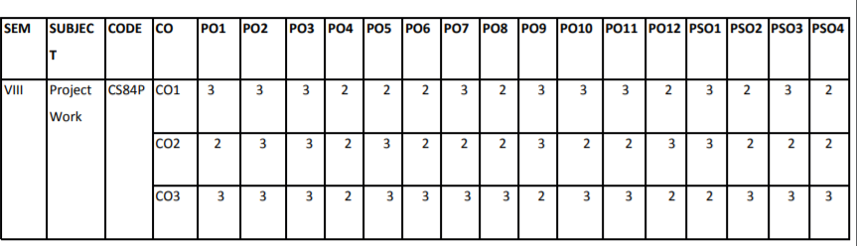

## References

[1] Anchit Shrivastava, Isha Jaggi, Shefali Gupta, Deepali Gupta “Handwritten digit recognition using machine learning: A review”

<https://ieeexplore.ieee.org/abstract/document/8976601/authors#authors>.

[2] Tsung-Han Tsai, Po-Ting Chi, Kuo-Hsing Cheng “The sketch classifier technique with deep learning models realised in an embedded system”

<https://ieeexplore.ieee.org/document/8724656/authors#authors>.

[3] Olisah Kingsley S and Mohamed Ismail Z “web-based E-learning for system for pre-school kids

<https://www.researchgate.net/publication/319360301_Web_Based_E-learning_System_for_Pre-school_Kids>

[4] Rahul Chauhan, Kamal Kumar Ghanshala, R.C Joshi “convolutional neural network (CNN) for image detection and recognition”

<https://ieeexplore.ieee.org/document/8703316>

[5] Kristine Guo, James WoMa, Eric Xu “Quick, Draw! Doodle Recognition” <http://cs229.stanford.edu/proj2018/report/98.pdf>